10/31/2003410800883AWayne Rolen PROOF OF REPRESENTATION

I, Claimant / Full Name), hereby inform the Centers for Medicare & Medicaid Services (CMS) that I grant the individual(s) listed below the authority to represent me and act on my behalf with respect to my claim, including releasing identifiable health information or resolving any potential recovery claim that Medicare may have in the event of a settlement, judgment, award, or other payment of that claim.

Type of Medicare Beneficiary Representative:

(X) Individual other than an Attorney: Marker 28
444 Broadway, Suite 306
Saratoga Springs, NY 12866

Medicare Beneficiary Information and Signature/Date

Beneficiary’s Name (please print exactly as shown on Medicare card):

Beneficiary’s Health Insurance Claim Number (number on Medicare card):

Date of Illness/Injury:

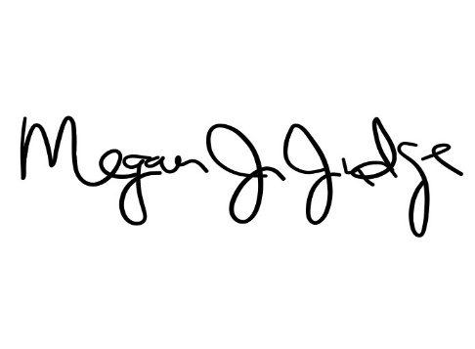
Beneficiary Signature: Date signed:
Claimant / Full Name»

Representative’s Signature:
Date signed:

Megan Judge/ Principal

Please forward all correspondence to:

Marker 28
444 Broadway, Suite 306
Saratoga Springs, NY 12866
Fax: 833.288.7285

